# **Tasks**

**Learners have to develop a dashboard to support the answers to the following questions.**

**Objective Questions**:

1. **What is the total no. of attributes present in the data?**

The "Tickets" sheet has 10 attributes (columns), and the "IT Agents" sheet has 6 attributes.

1. **Which columns have inconsistent or missing values, and what is the count of such values?**

There are no columns with missing or inconsistent values in either the "Tickets" or "IT Agents" sheets; all columns in both sheets are complete. ​

1. **What is the average daily ticket volume over time?**

The average daily ticket volume over time is 53.36.

1. **What is the distribution of ticket categories (e.g., Login Access, System, Software)?**

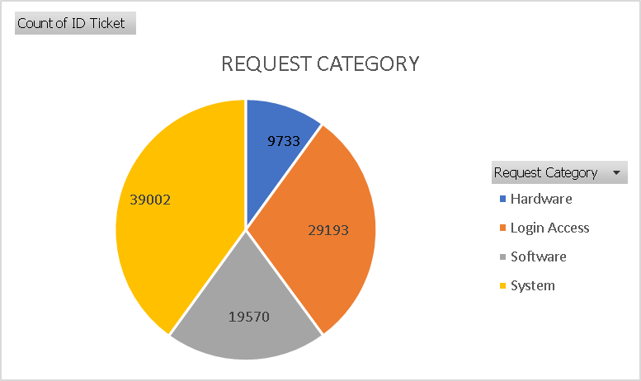The distribution of ticket categories are Login Access, System, Software and Hardware.

1. **How many tickets has each agent handled?**

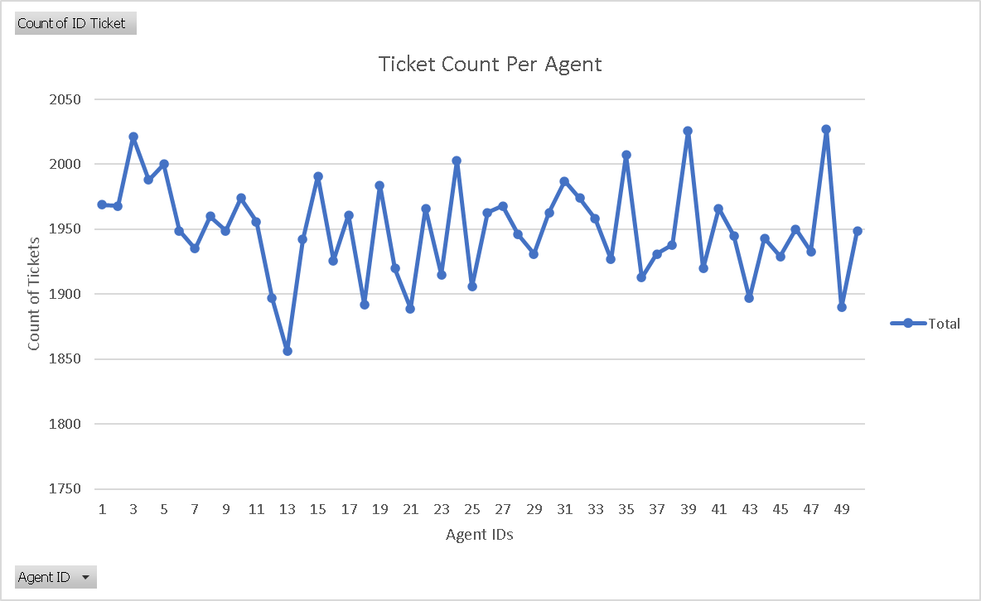Each agent has handled an average of 1949.96 tickets. As there are 50 agents and total number of tickets are 97499.

1. **How can you extract the domain from the email addresses in the IT Agents sheet?**

To extract the email address in the IT agents we can use mid() and find() string functions combined.

=MID(C2,FIND("@",C2)+1,FIND(".",C2,FIND("@",C2))-FIND("@",C2)-1)

1. **How can you find the full name of an agent given their Agent ID?**

The full name of employee can be found using vlookup function.

i.e =vlookup(agent_id,table_array,column_index,match_mode)

=VLOOKUP(D2,IT_Agents[[#All],[Agent ID]:[Day of Birth]],2,0)

1. **What is the count of each issue type (e.g., IT Error, IT Request)**

The count of issue for IT ERROR and IT Request is 24278 and 73220.

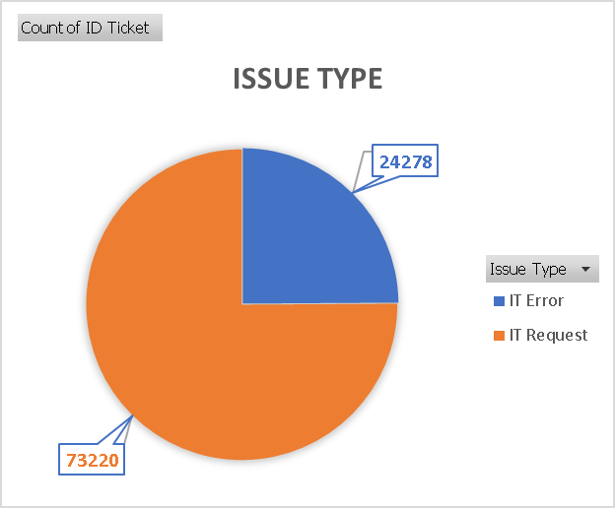

1. **What is the daily average resolution time for tickets?**

The average of daily average resolution time for tickets is 4.55 days per ticket.

1. **How has the volume of tickets changed over time?**

The volume of tickets has changed significantly over time. It has increased to 29088 in the year 2020 from 13051 in the year 2016.

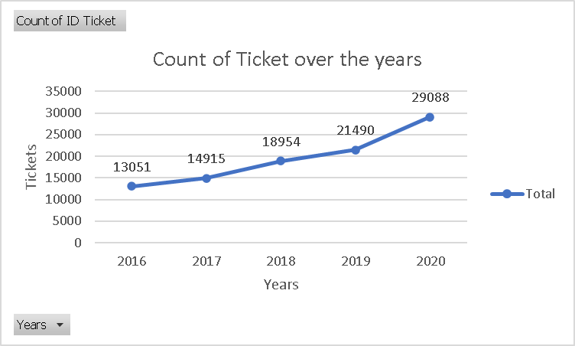

1. **What is the average age of the IT agents?**

The average age on IT agents is 39.42 years.

Firstly I calculated the date of birth in the IT Agents sheet using date function =DATE(D2,E2,F2).

Then added an adjacent column to calculate the age of employees by using datedif function =DATEDIF(G2,TODAY(),"y")

1. **Is there a correlation between the severity of issues and the resolution time?**

As we can observe when the severity of issue is “Urgent” the resolution time is taken by agents is the least as compared to other types.

Also when the severity of issue is “Normal” the resolution time taken by agent is the most.

We need to put more efforts into solving normal severity tickets along with other types so that the satisfaction rate will also get a elevation.

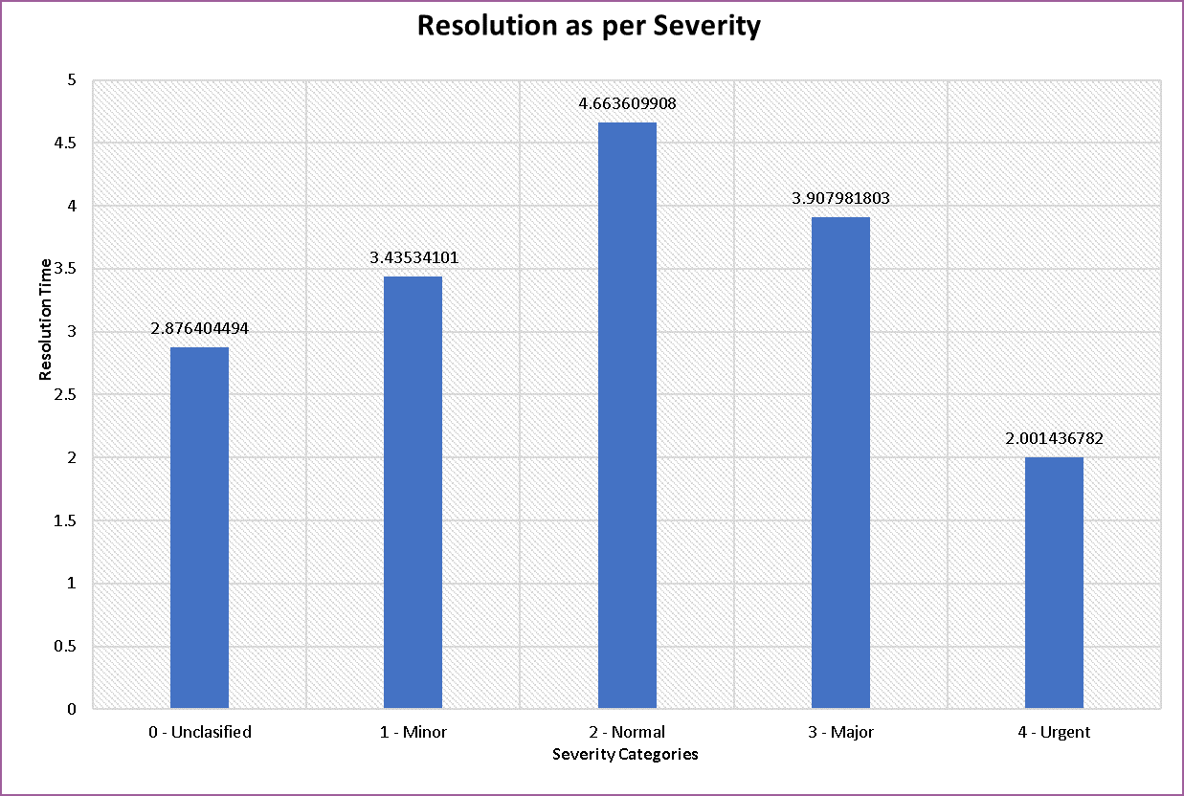

1. **How many categorical columns are there in the data? [Search about categorical and continuous data, and try to answer this question]**

The categorical columns present in sheet Tickets are 4. i.e (Request categories, Issue Type, Severity, Priority)

There are no categorical columns in the sheet IT Agents.

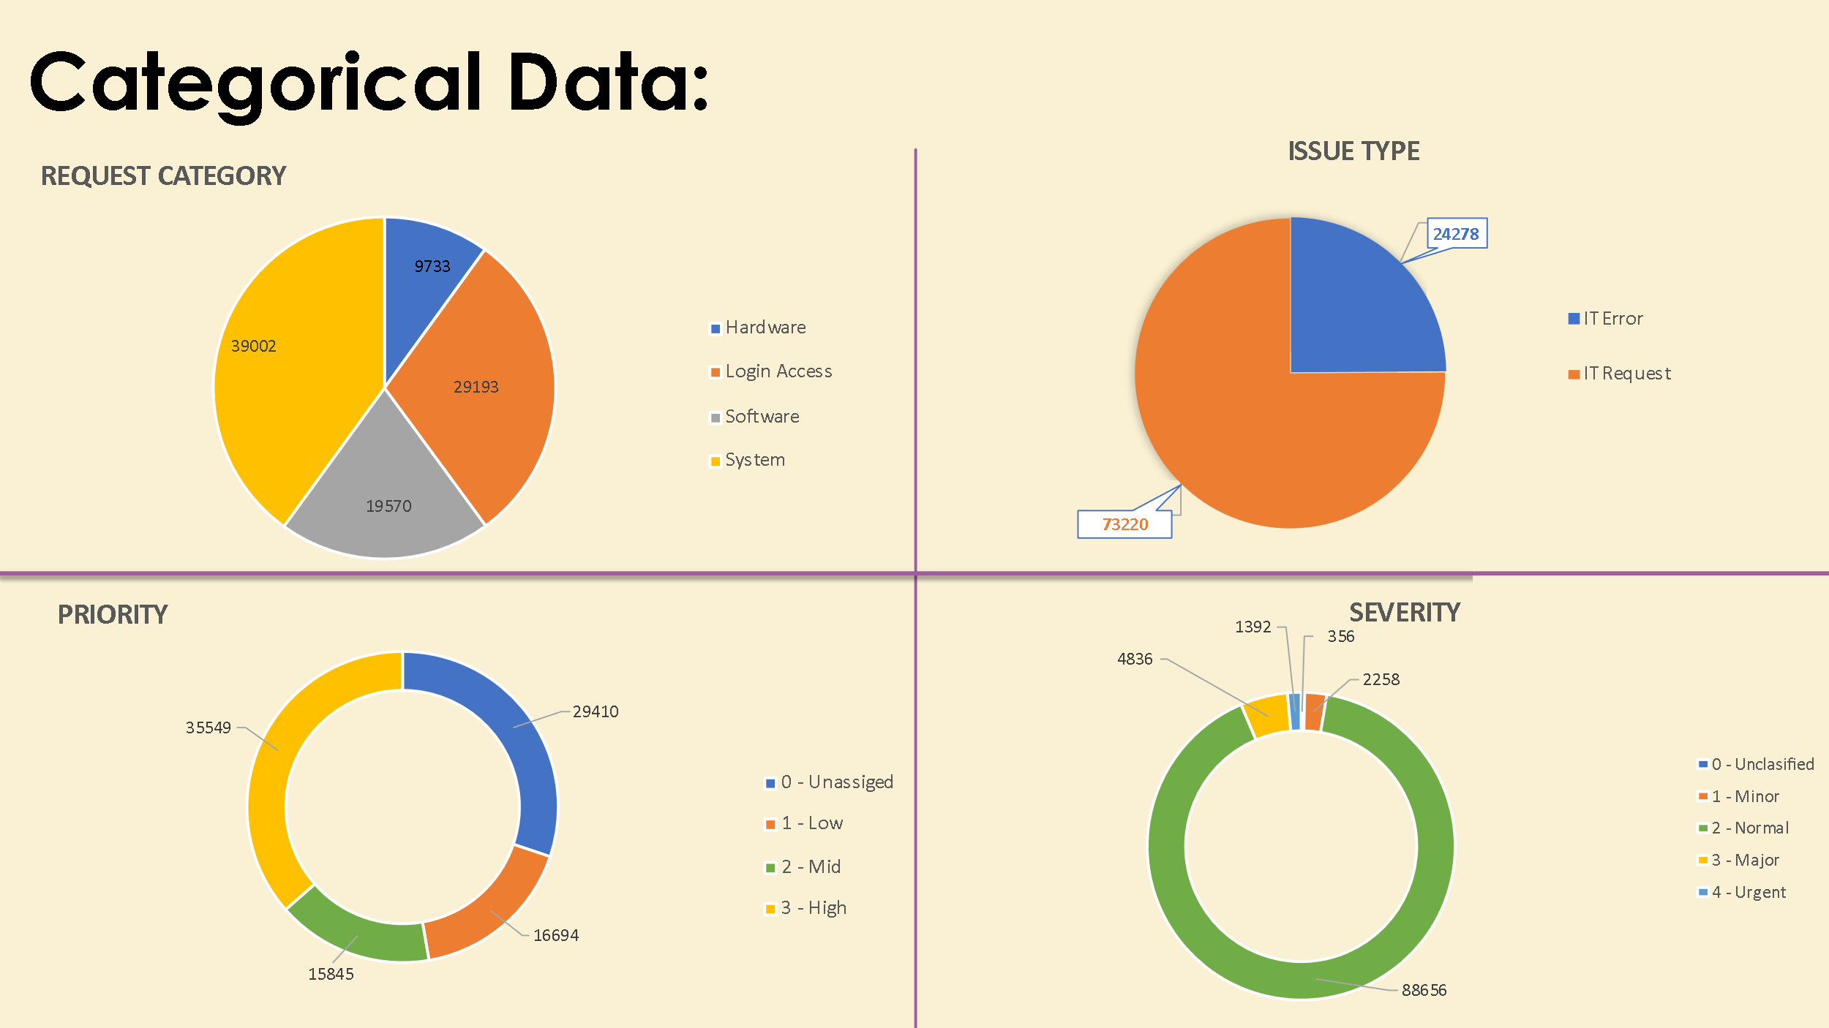

**Subjective Question:**

1. **If there is an investment, should it be used to hire more IT agents, improve training programs, or upgrade ticket management software?**

**Analysis: Perform a cost-benefit analysis using ticket resolution and satisfaction metrics.**

**Observations & Insights:**

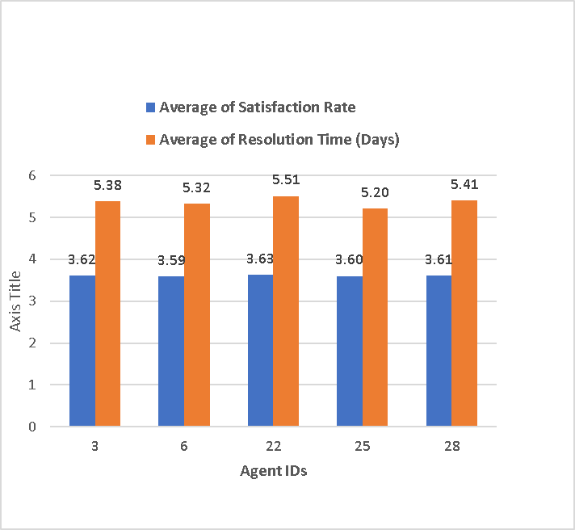To determine whether to invest in hiring more IT agents, improving training programs, or upgrading ticket management software, a cost-benefit analysis was conducted based on key metrics like ticket resolution time and satisfaction rate. Data from the "Satisfaction and Resolution" sheet indicates an **average satisfaction rate of 3.61** and an **average resolution time of 5.37 days**. These figures suggest room for improvement, especially in reducing resolution times to enhance customer experience.

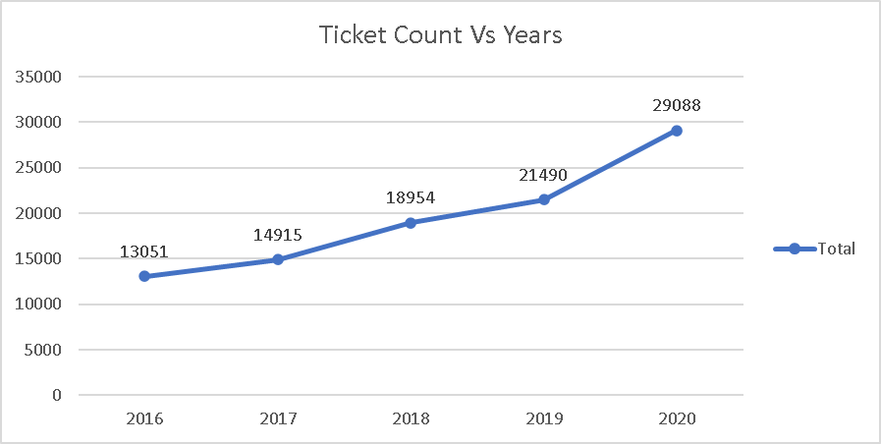**Hiring more IT agents** is likely to reduce resolution times by increasing the team's capacity to handle tickets promptly. As the below line graph shows that the ticket volume keeps on increasing over the years. The variation in the handling of such tickets by limited agents can be a vital indication of hiring more agents as well as training them.

**Improving training programs** can enhance both satisfaction rates and resolution times. Skilled agents are better equipped to resolve issues efficiently and provide a superior customer experience. If agent-level data shows significant variance in resolution performance, targeted training can bridge these gaps. Additionally, training can address patterns identified in tickets, as seen in the "Tickets" or "Request Categories" sheets, to reduce repetitive issues.

**Conclusion-**

A comprehensive review of the above factors will clarify which investment yields the best return.

For instance, if bottlenecks are caused by high workload and delays, hiring more agents is the most effective choice.

If inefficiencies stem from skill gaps, training should be prioritized. If tools are outdated, software upgrades may be critical.

A balanced approach, combining two or more options, might provide the best results for both resolution speed and customer satisfaction.

1. **Which agents need additional training based on their performance**

**metrics?**

**Analysis: Identify agents with the lowest satisfaction ratings and longest resolution times.**

**Insights:**

To identify agents who need additional training based of their performance metrics, the highest value for average satisfaction rate of an employee is 4.59 and the lowest value if average resolution time is 5.55 days.

So we can consider ideal values for agents who require improvement as below:

Average Satisfaction Rate **< 3.65**

Average Resolution Time **> 5 days**

Which will give the list of agents who require additional training.

**Visualization:**

|  |  |  |  |
| --- | --- | --- | --- |
| Row Labels | Average of Satisfaction Rate | Average of Resolution Time (Days) | Name of Agents |
| 6 | 3.592611596 | 5.32067727 | A. Trejo |
| 25 | 3.601259182 | 5.204616999 | Sandra Lujan |
| 28 | 3.612024666 | 5.409558068 | Nurio Zepeda |
| 3 | 3.615042058 | 5.381989114 | Elena Velez |
| 22 | 3.628179044 | 5.511190234 | Lorena |

1. **Do certain categories of requests have longer resolution times?**

**Analysis: Analyse the resolution times by request category**.

**Insights:**

As per the analysis there are four different request categories as Hardware, Software, System and Login Access. Each request category has a different resolution time which is as follows:

Hardware -7.62539813

Login Access -0.313808105

Software -5.238732754

System -6.615609456

**Visualization-**

1. **How effective are the current software tools in managing IT tickets?**

**Analysis: Evaluate performance metrics before and after the implementation of new tools.**

**Visualization:**

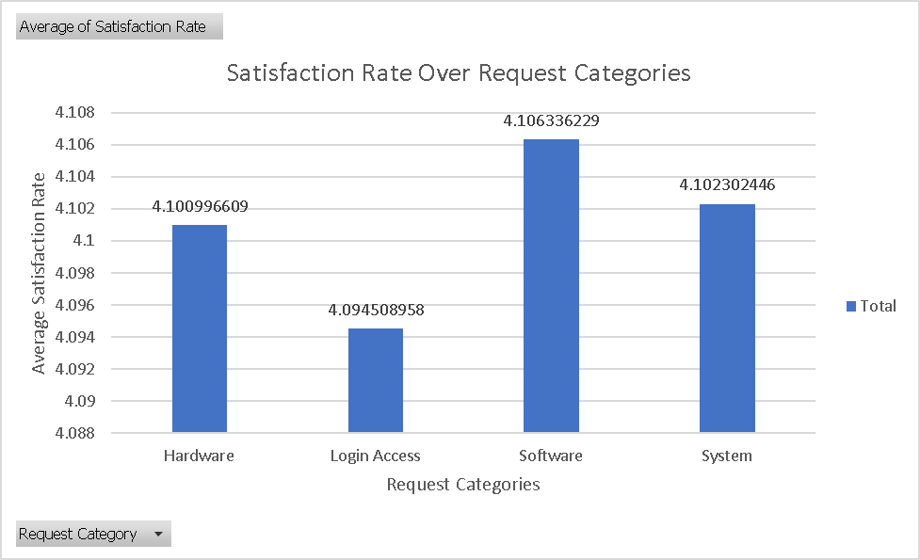

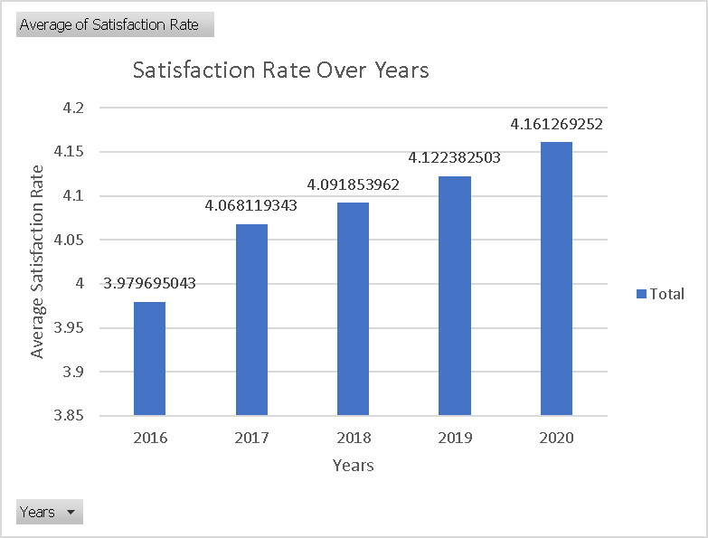

**Insights:**

If we consider that there were new software tools upgraded to handle the tickets after 2017, we are able to see a spike in satisfaction rate from 2018 to 2020.

If any new implementation were made then surely it has affected the software tools on a greater extend.

Also the there are improvements needed toward Login Access and Hardware Categories in order to get more satisfaction rate.\

1. **How has the performance of the IT support team changed over time**

**(e.g.,monthly or quarterly)?**

Insights:

Consistent Improvement (2016–2019): The IT support team's satisfaction rates show a steady upward trend, improving year by year, with the highest performance in 2019.

Peak Performance in 2019: Satisfaction rates across all quarters in 2019 were above 4.13, with Q2 reaching the highest value (4.14).

Slight Dip in 2020: A minor decline in satisfaction was observed in 2020 compared to 2019, though the rates remained higher than in 2016–2018.

Quarterly Consistency: Across all years, satisfaction rates across quarters were relatively consistent, with no extreme fluctuations within the same year.

Strong Long-Term Growth: The overall trend reflects a significant improvement in the IT support team's performance from 2016 to 2020, indicating effective enhancements in customer satisfaction efforts.

Visualization-

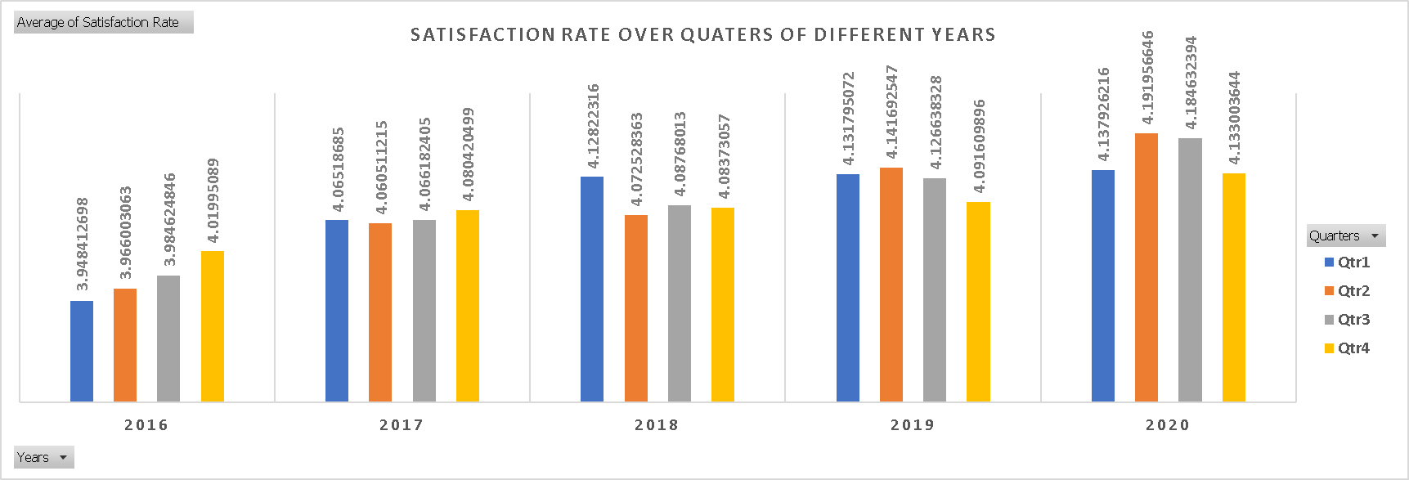

1. **If we invest more on tech (Hardware, software, etc), do you think it will**

**improve the ticket resolution times and employee satisfaction?**

**Analysis: Use historical data to project potential improvements.**

**Insights:**

Investing more on hardware and software would have a positive impact on the hardware, software as well as login access categories resulting in better resolution time and possibly increasing the satisfaction rate.

As for login access the resolution time is the lowest and it does not require any specific improvements.

**Visualization-**

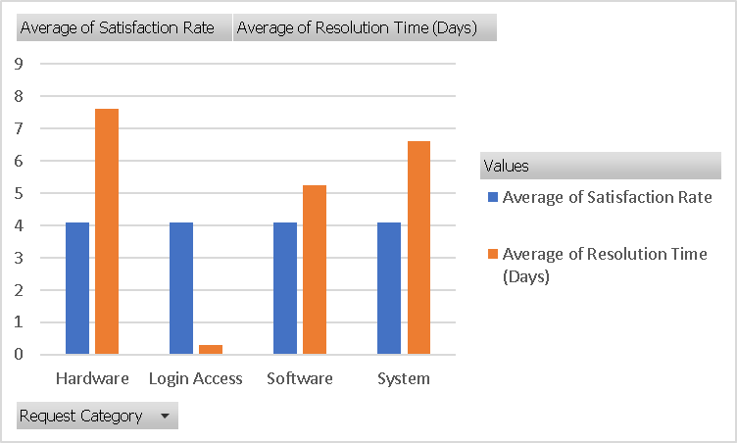

1. **What are the key performance metrics for IT agents, and how can they be**

**improved, do we need to fire any agents?**

**Analysis: Define and analyse metrics such as average handling time, satisfaction scores, and number of tickets resolved.**

**Visualization-**

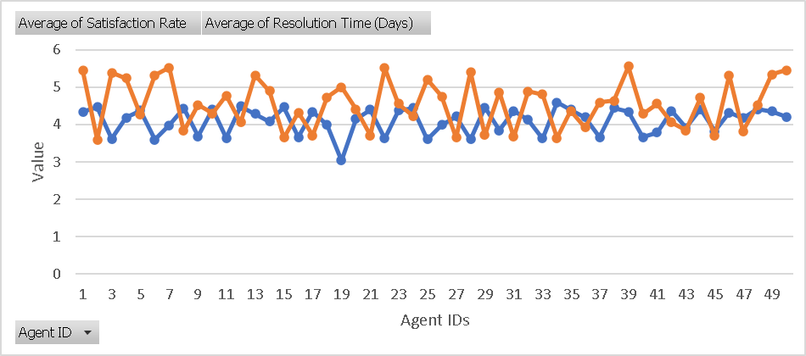

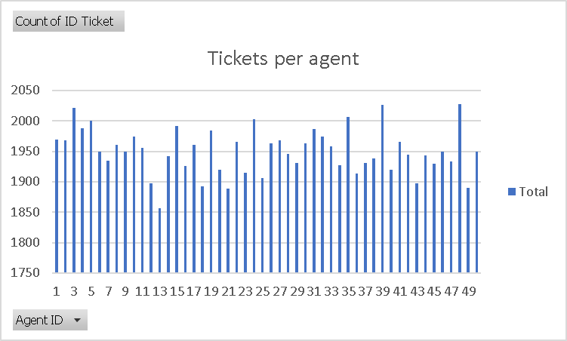

**Insights:**

From both the charts we are able to tell that there is a slight difference between resolution time and the ticket count of each agent is different with a minor change in average satisfaction values.

There are 50 agents in total who have handled 97498 tickets over 1827 days. Over this spam the average satisfaction rate was 4.10 and the average resolution time as 4.55 days.

|  |  |  |  |  |
| --- | --- | --- | --- | --- |
| Row Labels | Average of Satisfaction Rate | Average of Resolution Time (Days) | Name of Agents | Age |
| 6 | 3.592611596 | 5.32067727 | A. Trejo | 36 |
| 25 | 3.601259182 | 5.204616999 | Sandra Lujan | 36 |
| 28 | 3.612024666 | 5.409558068 | Nurio Zepeda | 42 |
| 3 | 3.615042058 | 5.381989114 | Elena Velez | 31 |
| 22 | 3.628179044 | 5.511190234 | Lorena | 28 |

The least average satisfaction rate value 3.59 is for Agent No–6 also the most average resolution time taken is 5.5 days by Agent No–22. Based on this analysis we can improve these agents skills with an additional training along with the below mentioned agents or decide to fire them if we are able to hire the right people for the

1. **How do employee demographics (e.g., department, seniority) impact**

**satisfaction and ticket outcomes?**

**Analysis: Segment analysis using filters and pivot tables.**

The seniority of the agents do have an impact on satisfaction rate inversely. But considering the resolution time it wont have a greater impact overall.

**Insights:**

In order to analyse the data more efficiently, the age has been grouped into 5 groups which starts from 28-32 as lowest to 48-52 as the highest.

If we observe the age group 33-37 is performing the least with the values of Average Satisfaction Rate = 3.98 and Average Resolution Time= 4.84.

This performance is the least ideal as compared to other age groups.

The senior most age group 48-52 is performing the most in aspects of Average Resolution Time= 4.11.

The age group 28-32 is performing the most in aspects of Average Satisfaction Rate=4.20.

**Visualization-**

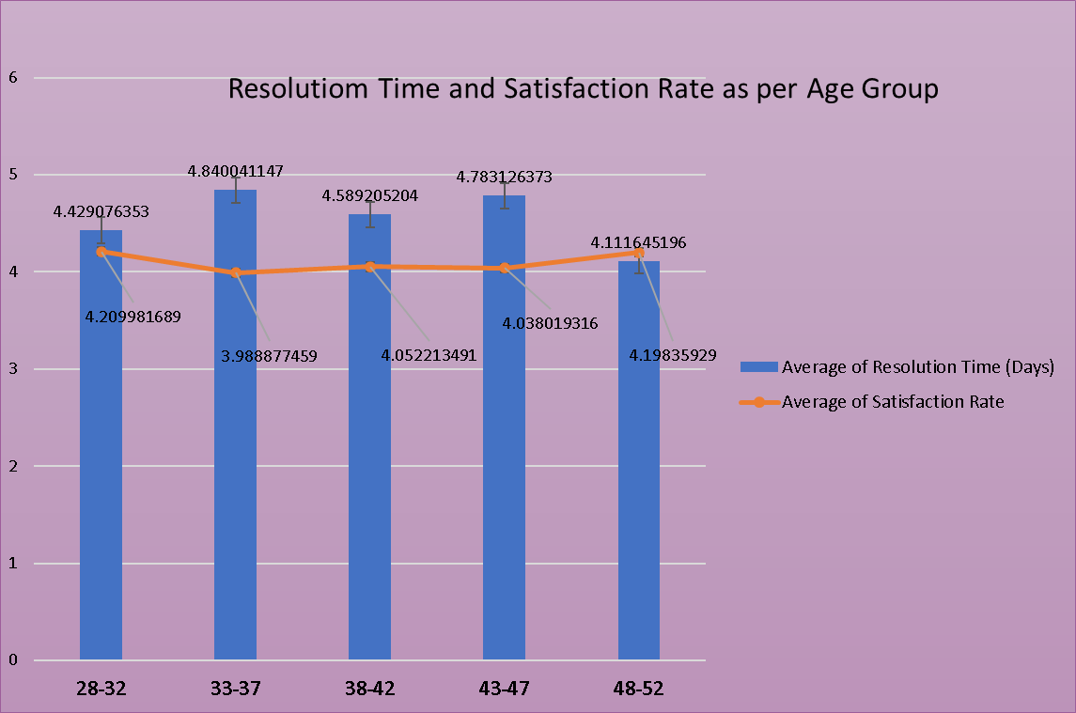

1. **Identify the trends for IT support operations based on ticket volumes and**

**satisfaction, and mention the peak and stable times?**

**Analysis: Use pivot tables and charts to identify peak and off-peak hours.**

**Insights:**

The peak times when the tickets volume is more than average is in Quarter 4 of every year and peak value is 7684 in 2020.

Also Quarter-1 and Quarter-2 of every year show stable times as compared to other Quarters of every year.

The Year 2016 was the most stable as in every quarter as the ticket volume

not took much jump and maintained values between 3200-3300.

**Visualization-**

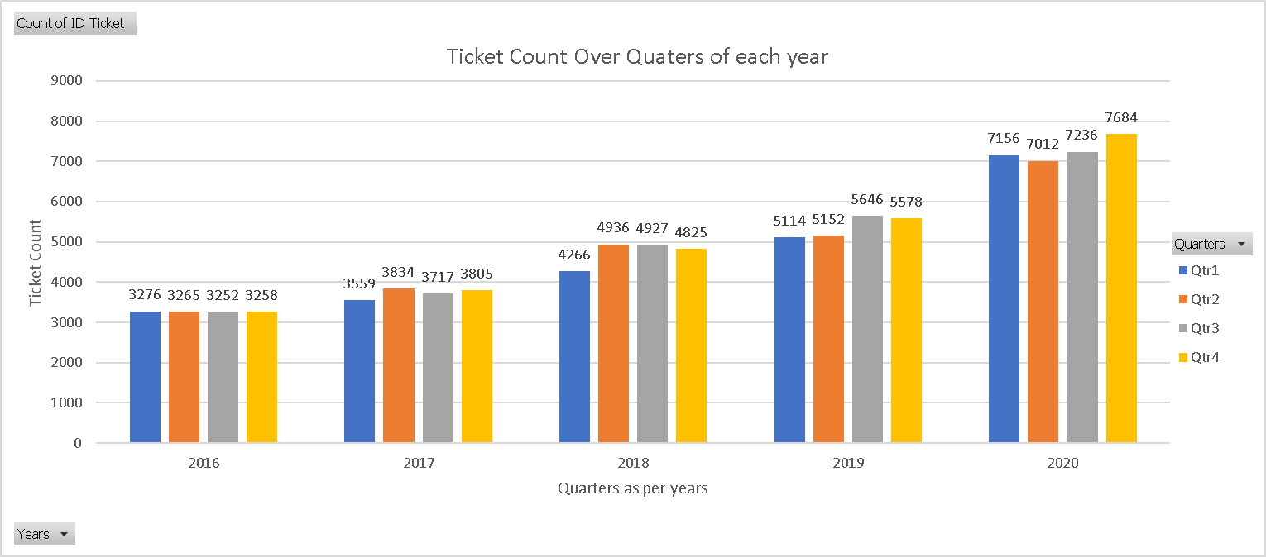

1. **What metrics should be included in the final dashboard to provide**

**comprehensive view of call centre performance and guide investment**

**decisions?**

The metrics that should be included in the final dashboard are:

* Ticket count trends over time and by category to understand volume and focus areas.
  + Total ticket volume by day, week, and month.
  + Breakdown by ticket type (e.g., technical, billing, general inquiry).
  + Peak hours and days for ticket submission.
* Satisfaction rates segmented by time, age group, and ticket severity to gauge customer experience.
  + Net Promoter Score (NPS) trends.
  + Age group-specific satisfaction scores.
  + Satisfaction by ticket priority (e.g., low, medium, high).
* Average resolution time by request category to identify efficiency improvements.
  + Resolution time by agent and team.
  + Trends in first response times.
  + Escalation rate and time for critical tickets.
* Distribution of tickets by satisfaction score and resolution time to analyze service quality.
  + Cross-analysis of high-resolution time with low satisfaction scores.
  + Percentage of tickets resolved within SLA.
  + Clusters of satisfaction scores by resolution time.
* Agent performance metrics to assess and improve team productivity.
  + Number of tickets handled per agent.
  + Average handle time per ticket.
  + Customer feedback and ratings for individual agents.
* Trends in satisfaction rate and resolution time across years, quarters, and months for long-term insights.
  + Quarterly comparisons of key performance indicators (KPIs).
  + Year-on-year improvement rates.
  + Seasonal variations in customer feedback and resolution metrics.

**Ensure that you put the slicers for choosing the priority wise and year in order to observe the dashboard since the management will be having a long discussion which can go for weeks.**

**Note: The dashboard would be more interactive and user-friendly, allowing management to explore data in detail and make informed decisions.**